**Material 9 – I understand more language than I think.**

|  |  |
| --- | --- |
| Why ? | Aims and contents:  The activities aim to encourage children to   * be aware that they can understand a lot of language through observation and context (e.g. ELP Junior version, Switzerland, page 56)   Targeted competences:   * I can identify written words in an unfamiliar language (CARAP, skills, S2-2-2) * I am curious about languages (CARAP, attitudes, A3) * I can understand familiar names, words and very simple sentences, for example on notices and posters or in catalogues. (CEFR, Reading A1) |
| What ? | Vocabulary and language structures selected by children  Comprehension strategies  Intercultural communication |
| How ? | The teacher and the children would go round the new surroundings and look carefully at words on shops, signs, posters, advertisements, etc. in order to decode them.  In mixed groups (home and host), children would write down some of the language they see in their new surroundings. They will try to find out what it means and the host children will help them pronounce the new language correctly. |
| Product | List of new language, included into European Language Portfolio - paper or virtual version |

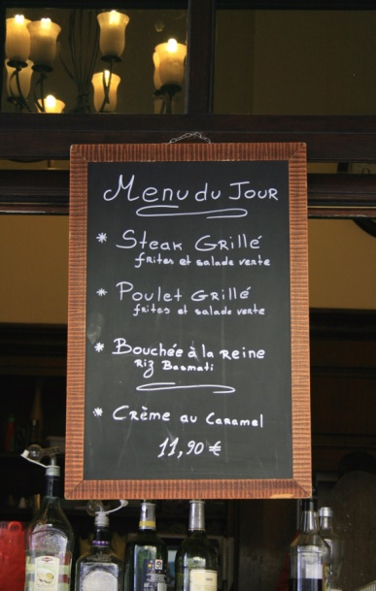 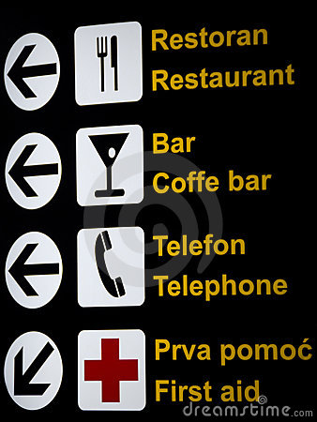

Figure 3: Extract from the Swiss edition of the European Language Portfolio I (ages 7-11)

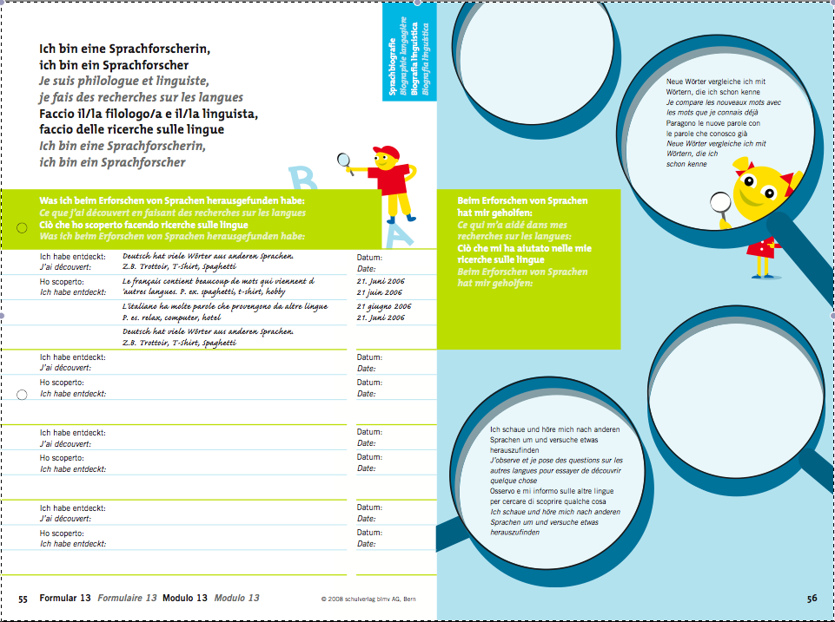

Source: www.schulverlagplus.de/81099.